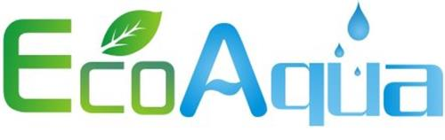

EcoAqua AP2-C401-SG (Mini Lincat) Compatible Cartridge
Code: EWF8002A

Fits the following filters:
3M® AP2-C401-SG, LINCAT® FC02

Operating Specifications:
Minimum operating temperature 0.6°C/33°F
Maximum operating temperature 38°C/100°F
Min. working pressure 140 kPa/20 psi
Max. working pressure 827 kPa/120 psi
Rated capacity 4,000 litres/1,060 gallons
Flow rate 1.9 lpm/0.5 gpm

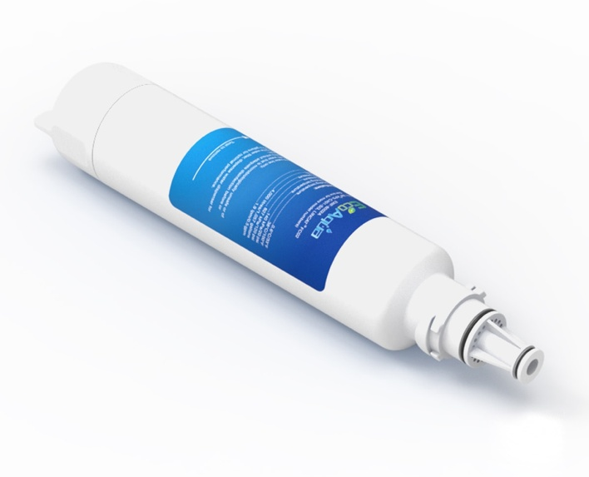

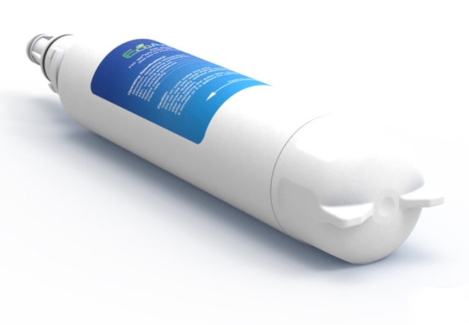

Distributed by:
Aqua Cure Ltd,
Aqua Cure House, Hall Street,
Southport, PR9 0SE.
Tel: 01704 516916
www.aquacure.co.uk
sales@aquacure.co.uk

